**VILLAGE OF LENA, WI**

**OCONTO, WISCONSIN**

**RESOLUTION NO. 2025-06**

**ADOPTING UPDATED SEWER SERVICE CHARGE RATES**

**WHEREAS,** the Village of Lena provides sanitary sewer service within the sewer service area; and

**WHEREAS** the Village of Lena, Oconto County, Board of Trustees (the “Board”) has authority to fix and collect charges for solid waste collection and disposal, sewage service and water service under Wis. Stats. 66.0821; and

**WHEREAS** the Board has reviewed all operation, maintenance, replacement and debt service of all waste treatment services provided by the sewer utility through a Study conducted by a third party and presented to the Village of Lena Finance Committee July 15th, 2025; and

**WHEREAS** the Board has determined a need to revise the charges imposed upon sewer service users to maintain the proportionality among user classes of the service charge system, and to ensure sufficient revenues are available to recover actual costs and pay total operation, maintenance, and replacement costs of the utility.

**WHEREAS** to close on a Clean Water Fund Loan with the State of Wisconsin the utility needs to prove adequate revenues applying the new sewerage rates to the volume and number of customers billed in the last fiscal year net current expenditures from the last fiscal year would have resulted in net revenues greater than 1.10 times the new debt service.

**NOW, THEREFORE, BE IT RESOLVED** the Board the following Sewer Service Charge and Fee Schedule effective on the following dates:

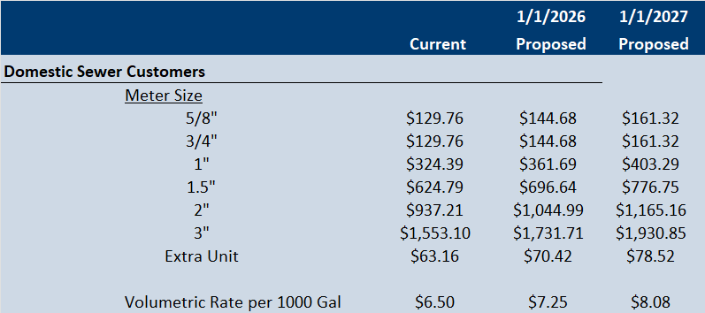

Adopted by the Village of Lena, Oconto County, Board of Trustees on this 18th day of August 2025.

APPROVED ________________________________Steven A Marquardt, Village President

ATTEST _________________________ ______ Jodi Marquardt, Village Clerk